

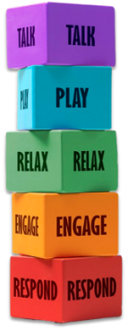
How to support a non-verbal child using Five to Thrive
Block 1: Respond: – Tune into Non-Verbal Cues
Observe body language, facial expressions, gestures, or sounds. A child might tug your hand, point, or use eye gaze to communicate. Respond promptly and consistently to these cues to build trust and show the child they are understood.
Block 2: Engage: Connect in Their Comfort Zone
If physical touch is soothing, offer cuddles. If not, engage through parallel play, shared interests, or simply being present. Respect sensory preferences—some children may prefer deep pressure (like weighted blankets) or gentle touch, while others may not want physical contact at all.
Block 3: Relax: Create a Calm, Predictable Environment
Use visual schedules, sensory-friendly spaces, and calming routines to reduce anxiety. Incorporate sensory breaks and quiet time. Tools like noise-cancelling headphones or fidget toys can help regulate sensory input.
Block 4: Play Use Play as a Language
Follow the child’s lead in play. Use toys, sensory bins, or cause-and-effect games to build interaction. Play can be a powerful way to model communication—use gestures, signs, or picture cards during play to introduce new concepts.
Block 5: Talk: Support Alternative Communication
Use AAC tools (Augmentative and Alternative Communication) like picture cards or speech-generating devices), sign language, or visual aids to support expressive and receptive communication. Narrate what you’re doing, even if the child doesn’t respond verbally. This builds language exposure and models communication.



For more information, please visit F amilyHubsLeicestershire.org.uk

