Welcome to our summer edition of the Family Hubs Newsletter. Apologies it’s been a while since we shared updates, lots has been happening and as ever, time just seems to slip away!

Firstly, we have a few key staff changes to announce. Ellie Lowe has now moved over to lead the Families First Partnership work, so we welcome Rachael Underwood as Interim Service Manager for TFH.

During the summer Targeted Family Help teams have been busy delivering summer HAF activities. Last year, as a service we supported 641 families and 1399 children through HAF. Those are such phenomenal numbers which I expect we’ll beat this year.

A few headline numbers from our incredible service:

In 24/25 we had:

* 10,674 contacts with families
* 3004 young people access support at a school-based

drop-in clinic

* 12,086 attendees at stay and play sessions

**Updates from the Equality Diversity and Inclusion Champions**

**Munira Bhula – Melton and Harborough**

We ran 4 HAF events over the summer thinking about individual family’s needs and catering for this- so we have:

1. Family event in Melton- theme is picnic in the park- lots of fun physical health game as well as painting stones to cater for different needs. We shall be having Melton Sports Team/ Waste Team supporting us on the day. 1 of the recipes given to family will be around what is a Plantin and how to cook this as we will be adding recipes for 5 things you can make with a banana and wanted to show and highlight the different between banana and a Plantain.

2. SIBs event which will replicate the above theme and will allow siblings of a send child to attend a safe space and have some fun.

3. Young People’s event- this is for YP without parents/ carers to have some fun at outdoor pursuit centre, taking part in Archery and Kayaking for 10 years and over.

4. Farm Trip for families at Windmill Farm- family day out

We shall also be running 3 SEND parent café sessions allowing parents/ carers to attend with their children and activities will be provided, this is to ensure support is provided for the SEND families over the holidays

Stay and Play- Pop Up’s by our volunteer team over the 2 area ‘s

Summer Pathway Groups- looking at trips to local park catering for little ones as well as siblings they may bring along and also to support families to be outdoors and enjoy time as a family.

We shall be teaming up with Melton Churches 4 U who will be providing 4 weeks of food list for families to cook and eat together as a family- recipes discussed will be in line with July EDI Callender south Asian heritage- as well as further recipes to try at home (mix and match) example- pasta will include recipes of masala pasta, chicken pasta, veg pasta, macaroni etc allowing families to choose their preference and learn

Another idea is rice- Caribbean rice, Spanish rice, biryani, veg rice, egg fried rice etc allowing us to educate families about different types of dishes and rice out there.

We will be signposting families to events over the summer within our locality and Leicester City- carnival dates, museum offer, theatre, library events etc- making it inclusive.

We shall also be leading with our trauma informed hats on ensuring all activities/ events are catered for families are trauma-informed and leaflets/ handouts are also printed in different languages to cater for the families we work with

**Triage**

The Family Help Triage team recently completed an activity in our team meeting to capture ideas of ways to embed EDI within our Triage practices. The team shared some brilliant ideas of simple ways to raise awareness & understanding of various protected characteristics and also ideas for targeted events such as guest speakers. We know we won’t be able to carry out all of the ideas all of the time, but in a busy Triage environment we are working hard to find manageable and purposeful ways to embed EDI into our work and celebrate culture & identity.



**Teen Health – Summer Update**

At Teen Health, our mission is to support and empower young people - and that means making sure every young person knows they are seen, valued, and safe exactly as they are.

For many LGBTQ+ teens, visibility, acceptance, and belonging can be life changing. In a time when many young people are navigating identity in the face of growing political and social challenges, showing our support during PRIDE isn’t just symbolic- it’s essential.

We’re proud to be attending two local PRIDE events this year, in Leicester and Hinckley. These celebrations allow us to show up in solidarity with the young people we work with, and to reinforce our ongoing commitment to equity, diversity, and acceptance.

In addition to our PRIDE involvement, we have other events taking place over the summer holidays. These include summer event days and group work opportunities. We know that summer can be a challenging time for many young people, and we’re committed to making sure that care and connection don’t pause when school does.

If you are working with a young person and believe that they would benefit from taking part in our summer activities or accessing individual support, please get in touch or visit the Teen Health website.

<https://www.teenhealth.org.uk/events/>

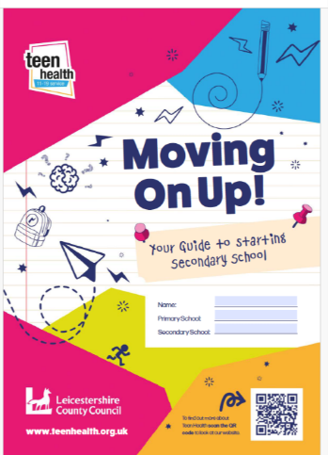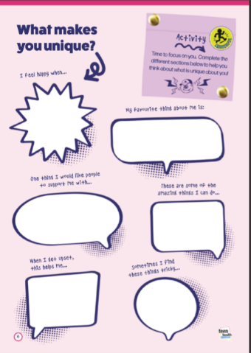

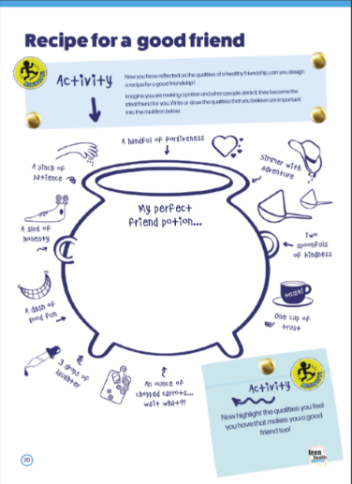

Teen Health is thrilled to share our new Transition to Secondary School booklet ‘Moving on up!’ – a fantastic resource to guide children through this exciting, yet often challenging time of their lives.

The 40-page booklet is aimed at all children starting secondary in Leicestershire and covers areas such as organisation, routines, friendships, support networks and emotional wellbeing. Children can work on it independently or with support from parents/carers, school or professionals. Its full of fun and exciting information, activities and challenges to help children feel more prepared and supported. It also includes top tips from young people too!

The booklet will be available on the Teen Health website from August; it can be printed out or the children can work on their own PDF digital version. We welcome everyone to share the resource widely.

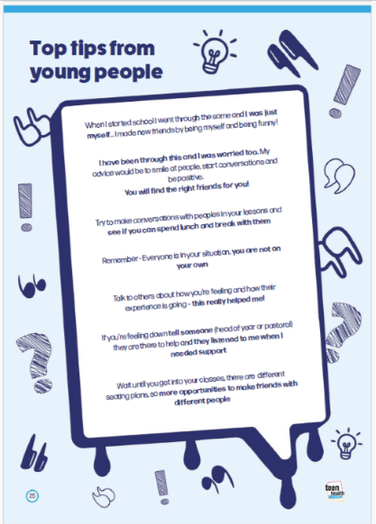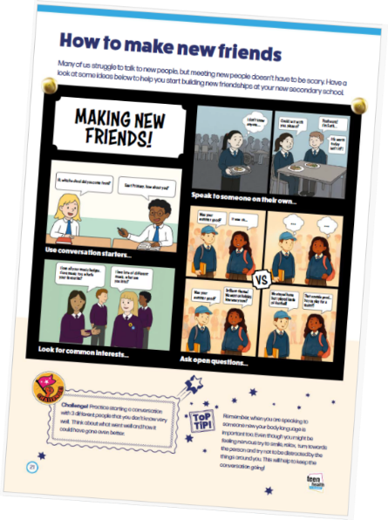

Training events for all

**EAST MIDLANDS REDUCING PARENTAL CONFLICT PRESENTS**

**THE DIFFERENCES BETWEEN DOMESTIC ABUSE AND PARENTAL CONFLICT**

Join us at one of our upcoming webinars designed for professionals in the East Midlands to learn more from the experts at Amity.  
  
You may find yourself supporting a family and wondering whether the behaviours you are seeing indicate domestic abuse or parental conflict. The two are very different (although can look similar), and it is important that professionals working with families are able to identify which is happening and know how to respond with the appropriate advice and support.

* Wed 17 Sep 2025, 10.00 AM - 12.00 PM
* Thu 13 Nov 2025, 1.30 PM - 3.30 PM
* Wed 4 Feb 2026, 10.00 AM - 12.00 PM

Book now - <https://linktr.ee/eastmidlandsrpc>

LEICESTER LEICESTERSHIRE & RUTLAND RPC Awareness Training and Early Years sessions are being delivered by Foxstones Training and Learning



Staff can Access an Oral Health/Healthy eating

E-Learning course

on the Healthy Tots Leicestershire website

[**https://www.leicestershirehealthytots.org.uk/oral-health-elearning**](https://www.leicestershirehealthytots.org.uk/oral-health-elearning)



**DWP Updates**

My name is Claire Winterton. Most of you know me as the Supporting Families Employment Advisor (SFEA), this title has changed now that the Supporting Families Programme has ended. My new title is Family Community Work Coach (FCWC). I’m still employed by the DWP and have a DWP manager, but I also have a manager in Targeted Family Help. This helps to make sure that I can integrate well with the service and meet the needs of TFH and the DWP. There have been some changes to the role, but don’t worry I’m still part of the team.

The FCWC initiative aims to drive growth and reduce child poverty by providing holistic support to families facing multiple disadvantages. This includes addressing parental unemployment, non-payment of child maintenance, NEET (Not in Education, Employment, or Training) status, and parental conflict. The initiative aligns with the "Get Britain Working" campaign.

Additionally, the FCWC initiative will collaborate with the Department for Education's Families First Partnership Programme to enhance family-focused support within the community.

So, as you can see, I can still help to support Family Help teams.

Having looked at the changes in the role I have been able to consider where my skills would be best suited to support your work.

I’ve covered the basics of what I can do to support here and will send a more detailed list of my role with a referral form in an email to you all.

Progress to work for all things 0-5

Direct support for your families, whether you are a Key Worker, Family Wellbeing Worker, Youth Worker, Social Worker, Early Responder, Extended Domestic Abuse Worker or Brighter Futures Worker. I can help you to find the right information and services.

Deliver specific sessions at Clinics/Drop ins/Coffee Mornings in Family Hubs

Link with Volunteer Development Officers at county hall around volunteering as an early step to employment

Attend SEND parent support groups to provide support, information and advice

Sign post families to services who can provide specialist input on their employment journey

I hope this gives you a bit of an overview of how I am embedded in Family help .

**Meet the Family & Community Navigators!**

The family hubs team have two new members of staff. We are picking up the baton from Hayley and will be out and about in team meetings, libraries and working on local projects. Together we will be out in communities promoting the family hubs website, using the library book bus as an avenue to get key information and messages to families living remotely. Additionally, we are exploring how to work more closely with faith-based groups /communities. They are currently in week 3 so busy with lots of fact finding and planning activity.

Hi I’m Sarah Ball and many of you will know me from the team in Hinckley & Bosworth where I was a Family Wellbeing Worker. I will be working with libraries in the west of the county where I will have a focus on working with districts and housing partners across NWL, Blaby, Oadby & Wigston and Hinckley and Bosworth. I will be working closely with Leicestershire GATE, and further developing the Maternity Champions approach in Loughborough. With Lucy, I will be learning new skills as we start to create new content for the website !!!

Hi I’m Lucy Day, some of you will know me as a CSA over in Melton and prior to this I was a teacher. I will be working with libraries in the east of the county. Also focusing on further development of a community-based response to early childhood GP appointments, looking at our relationships with faith-based communities and how to build increased awareness of the website for families to access. I will be working with Sarah looking at the Home Learning Environment and how to promote opportunities for learning at home.

**Home Learning Environment**

There are a number of fantastic resources on the LCC website all about The Home Learning Environment. These are a great tool to share with parents and carers and include items such creating a positive learning environment, toileting and hygiene, mealtimes, and early maths at home.

Click on the link below to browse the extensive range of resources-

<https://resources.leicestershire.gov.uk/education-and-children/early-years/early-years-foundation-stage-eyfs/learning-development-and-assessment/the-home-learning-environment>

**School Readiness**

For parents and carers who have children starting school this September, there are lots of resources to support this new transition.

<https://www.leicestershire.gov.uk/education-and-children/early-years-and-childcare/school-readiness>

You can also find Hot Topics and Articles on the Family Hubs website explaining how Five to Thrive can be applied to different scenarios. Such as :

* [Five to Thrive and supporting someone with mental health challenges](https://www.familyhubsleicestershire.org.uk/hot-topics/five-thrive-and-supporting-someone-mental-health-challenges)
* [Five to Thrive - activities to try at home](https://www.familyhubsleicestershire.org.uk/hot-topics/five-thrive-activities-try-home)
* [Five to Thrive and SEN Families](https://www.familyhubsleicestershire.org.uk/hot-topics/five-thrive-and-sen-families)
* [Five to Thrive - Why is your family support network important?](https://www.familyhubsleicestershire.org.uk/hot-topics/five-thrive-why-your-family-support-network-important)
* [How Five to Thrive can help families with financial worries](https://www.familyhubsleicestershire.org.uk/parents-and-carers/money-housing-and-employment) (scroll to bottom)
* [Bullying - support your child using Five to Thrive](https://www.familyhubsleicestershire.org.uk/parents-and-carers/education) (scroll to Bullying)

Parents and Carers can find more information about how Five to Thrive can encourage secure attachments to ensure brain development to support a child’s emotional resilience and communication skills. There are also downloadable resources such as a parent’s journal and an insert for their baby’s personal health records.

Professionals can find help with planning Five to Thrive sessions, suggestions how the approach can be used and downloadable resources such as the Mending Hurts workbook and parent/child guides

Did you know that the Family Hubs website now has a Five to Thrive page for [Parents and Carers](https://www.familyhubsleicestershire.org.uk/parents-and-carers/five-thrive) and [Professionals](https://www.familyhubsleicestershire.org.uk/professionals/five-thrive-practitioners)?

Any questions, contact Hayley Downing- [Hayley.Downing@leics.gov.uk](mailto:Hayley.Downing@leics.gov.uk)

Any questions, please email Hayley.Downing@leic.gov.uk

