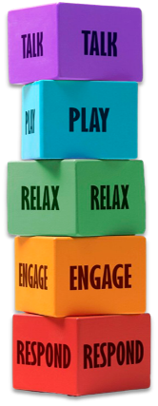How to support mental health challenges using Five to Thrive

**Block 1: Respond:**

Being attuned and responsive to others’ emotional and physical needs.

Mental health impact:

* Builds trust and emotional safety.
* Reinforces the idea that needs are valid and will be met, which is essential for self-esteem.
* Helps regulate stress and anxiety through co-regulation.

Example: A teacher notices a child withdrawing during group work and gently checks in. The child feels seen and valued.

**Block 2: Engage:**

Making eye contact, showing interest, sharing attention and affection.

Mental health impact:

* + Supports social connection and reduces feelings of isolation.
  + Boosts dopamine and oxytocin, improving mood and connection.
  + Encourages self-expression and builds confidence.

Example: A parent sits with their child during homework, offering encouragement and shared focus.

**Block 3: Relax:**

Creating moments of calm, rest, and emotional regulation.

Mental health impact:

* + Reduces cortisol (stress hormone) levels.
  + Helps develop self-soothing skills and emotional regulation.
  + Allows space for processing emotions and reducing overwhelm.

Example: A practitioner helps a child learn breathing exercises or creates a quiet, sensory-friendly space.

**Block 4: Play:**

Engaging in spontaneous, creative, and joyful activities.

Mental health impact:

* + Encourages emotional expression and problem-solving.
  + Boosts resilience and coping skills.
  + Strengthens relationships through shared joy and fun.

Example: A therapist uses play-based interventions to help a child explore feelings in a safe way.

**Block 5: Talk:**

Using language to name feelings, needs, and experiences.

* Mental health impact:
  + Builds emotional literacy—a key protective factor for mental health.
  + Encourages communication over behaviour, reducing misinterpretation.
  + Helps process difficult events through storytelling and narrative.

Example: A youth worker supports a teen in naming their feelings after a conflict with a friend, helping them make sense of their reactions.

**For more information, please visit** [**FamilyHubsLeicestershire.org.uk**](https://leics.sharepoint.com/sites/fivetothrivefamilyhelp/Shared%20Documents/03%20Phase%201%20-%20Family%20Help%200-19%20(Sept%202024%20-%20March%202025)/resources/FamilyHubsleicestershire.org.uk)

