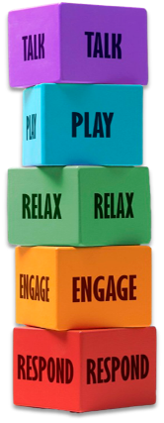How to support your child after school pick up using Five to Thrive

Using the **Five to Thrive** approach can be incredibly helpful for settling a child who is dysregulated after school pick-up. After a busy, often overstimulating day, children may feel overwhelmed, tired, or emotionally out of sync. Here's how each block can support a calmer evening.

**Block 1: Respond:**

Start by tuning in to your child’s emotional state. Are they angry, tearful, hyper, or withdrawn? Responding with calm, non-judgmental attention helps them feel seen and safe. A simple “You’ve had a big day, haven’t you?” can open the door to connection.

**Block 2: Engage:**

If your child is open to it, physical closeness like a hug, holding hands, or sitting side-by-side can help regulate their nervous system. It releases calming hormones and reinforces the message: *you’re safe, you’re loved*

**Block 3: Relax:**

Create a gentle, predictable after-school routine. This might include quiet time, a snack, or a favourite calming activity. Avoid rushing into homework or errands — give them space to decompress and reset.

**Block 4: Play:**

Play helps children process their day and release tension. It doesn’t have to be structured — even silly games, role play, or building something together can help them reconnect and feel grounded

**Block 5: Talk:**

When they’re ready, talking through their day helps them make sense of what happened. Keep it light and open-ended: “What was the funniest thing today?” or “Did anything tricky happen?” This builds emotional literacy and trust

For more information, please visit [FamilyHubsLeicestershire.org.uk](https://leics.sharepoint.com/sites/fivetothrivefamilyhelp/Shared%20Documents/03%20Phase%201%20-%20Family%20Help%200-19%20(Sept%202024%20-%20March%202025)/resources/FamilyHubsLeicestershire.org.uk)A white animal on a green background
