Respond

“When you copy the expression on my face, it helps me understand what I’m feeling” 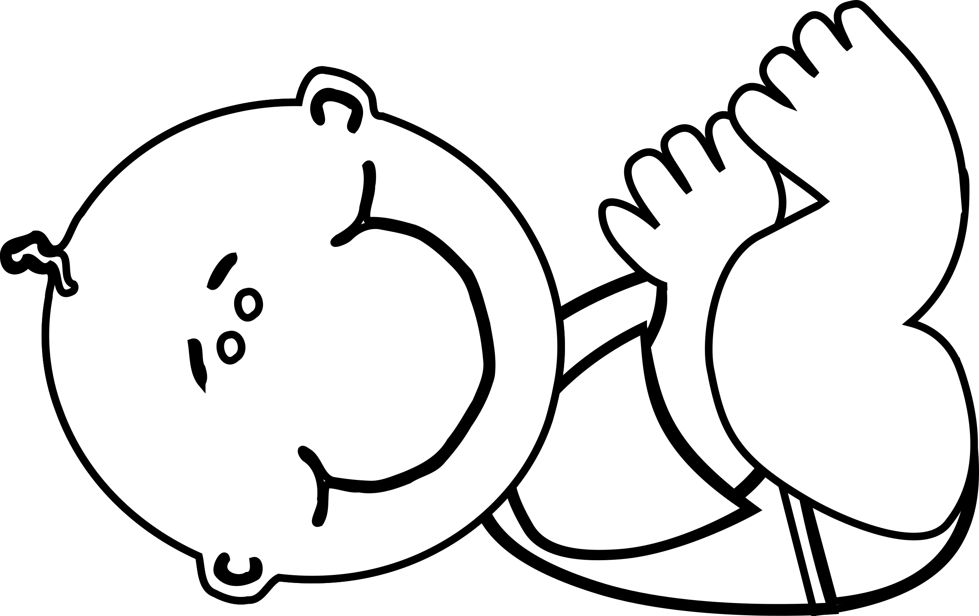
“From the moment I was born I needed you”
“I feel very scared if I get no response from you”

Cuddle

“Feeling safe with you fills my body with special chemicals that help my brain to grow”
“Connections are building in my brain that will make it possible for me to control my body one day”
“When I’m close to you my body begins to work in tune with yours”

Relax

“As I am young I have no way to calm myself down, so I need you to help me when I’m stressed”
“When we are stressed our bodies are full of chemicals which can be bad for my brain”
“When you relax your heartbeat slows down – and so does mine”
“Toys are great, but the best toy in the world for me is ...you!”
“I will need time to let my brain take in all that it’s learning: I might turn my head away for a while”
“Try to get down on the floor to play with me, or be face to face”
“I love the sound of your voice: I could hear it in the womb”
“I need you to tell me about things right from birth”
“I need you to listen to what I’m telling you”
Cuddle
Play

